ADITYA-L1 MISSION DATA ANALYSIS
Learning Module on Interplanetary Magnetic Field Analysis Using MAG Data

Submitted By
Smriti Sitoke
B.Tech – Computer Science and Business Systems
Oriental Institute of Science and Technology, Bhopal

Internship Organization
Macroedtech

Data Source Organization
Indian Space Research Organisation (ISRO)
ISRO Science Data Archive (ISSDC)

Project Title
Analysis of Solar Wind Magnetic Field Using Aditya-L1 MAG Level-2 Dataset

Tools Used
Python • Google Colab • NetCDF4 • NumPy • Matplotlib

Dataset Source
PRADAN – ISRO Science Data Archive

Academic Year
2025 – 2026

Table of Contents
1. Executive Summary ................................................. 1
2. Introduction ..................................................... 2
3. Aditya-L1 Mission Overview .................................... 3
3.1 Mission Goals ............................................. 3
3.2 L1 Point Advantages ...................................... 4
4. MAG Instrument Description ..................................... 5
4.1 Bx/By/Bz Components ..................................... 5
4.2 Measurement Units ........................................ 6
5. Dataset Description ............................................ 7
5.1 NetCDF Variables Table ................................... 7
5.2 GSE vs GSM Coordinates ................................... 8
6. Data Analysis Methodology ..................................... 9
6.1 5-Step Workflow ......................................... 9
6.2 Quality Filter Fix (=≤1) ................................. 10
7. Data Visualization & Plots ..................................... 11
7.1 Bx/By/Bz Time Series ..................................... 11
7.2 Total Magnitude + Threshold ............................. 12
7.3 Histogram Distribution ................................... 12
7.4 Parker Spiral Angle ..................................... 13
7.5 Hodogram (Bx vs By) ..................................... 13
7.6 3D Vector Trajectory ..................................... 14
8. Results & Scientific Interpretation ........................... 15
8.1 Key Statistics Summary ................................... 15
8.2 Disturbance Detection .................................... 16
9. Conclusion ...................................................... 17
10. Learning Outcomes .............................................. 18
11. References ..................................................... 19

List of Figures ..................................................... 20
List of Tables ..................................................... 21

1.Executive Summary
This document presents a comprehensive analysis workflow for Aditya-L1 Level-2 magnetometer data, demonstrating the extraction, processing, and visualization of Interplanetary Magnetic Field (IMF) measurements from India's first solar mission. The analysis focuses on data from February 27, 2026, captured at the Sun-Earth Lagrange point L1.
Key Findings:
- Total data points analyzed: 8,640 (10-second cadence over 24 hours)
- Mean magnetic field magnitude: 11.55 nT
- Bx component range: -17.98 to -5.92 nT (GSE coordinates)
- By component range: -8.05 to 0.99 nT
- Bz component range: -2.62 to 7.11 nT
- Maximum field strength: 18.93 nT
- Minimum field strength: 6.68 nT
These values align with typical IMF conditions at L1, validating the analysis methodology.
2. Introduction
The Sun continuously emits a stream of charged particles known as the solar wind. Embedded within this solar wind is the Interplanetary Magnetic Field (IMF), which originates from the Sun’s magnetic field and extends throughout the solar system.
Understanding the behavior of the IMF is essential for studying space weather, which can influence:
- satellite operations
- GPS systems
- communication networks
- power grids on Earth
To study these solar and heliospheric phenomena, the Aditya-L1 mission was launched by the Indian Space Research Organisation.
Aditya-L1 is India’s first dedicated solar observatory positioned at the Sun–Earth Lagrange Point L1, approximately 1.5 million kilometers from Earth. This location allows continuous monitoring of the Sun and the solar wind.
One of the important instruments on this spacecraft is the MAG (Magnetometer) instrument, which measures the magnetic field of the solar wind.
This learning module demonstrates how to analyze Aditya-L1 MAG data and interpret the magnetic field properties of the solar wind.

3. Overview of the Aditya-L1 Mission
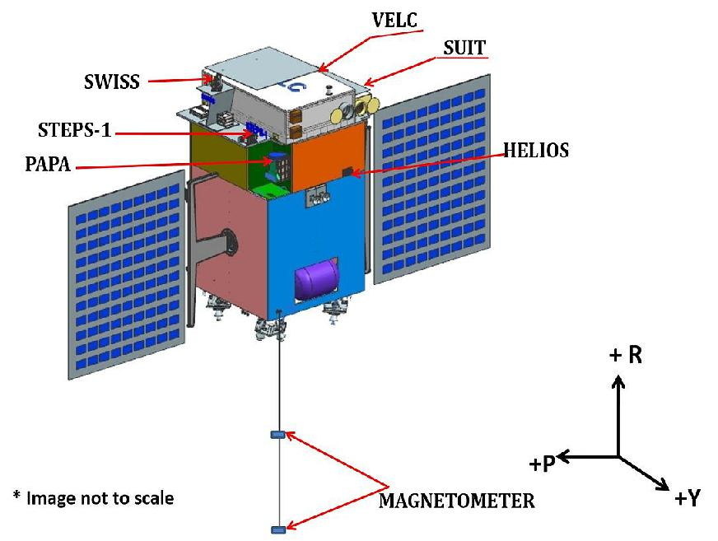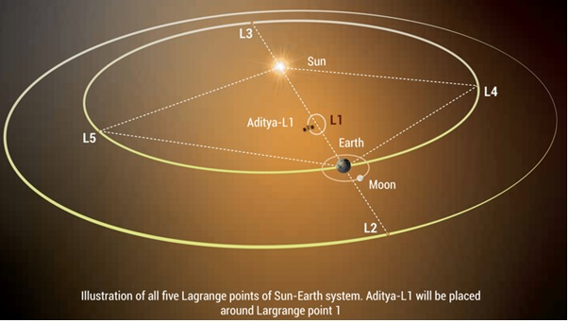


Aditya-L1 is India's first solar mission designed to study the Sun and the heliosphere.
Mission Goals
The mission aims to:
- study the solar corona
- analyze solar wind properties
- monitor space weather
- observe solar magnetic field structures
Location: L1 Point
The spacecraft is positioned at the Lagrange Point L1, where gravitational forces from Earth and the Sun balance. This allows the spacecraft to maintain a stable position while continuously observing the Sun.
Advantages of this location include:
- uninterrupted solar observations
- early detection of solar storms
- real-time solar wind monitoring

4. The MAG Instrument
The MAG instrument measures the vector magnetic field of the solar wind.
It records the magnetic field in three perpendicular directions:
Component | Description
Bx | Magnetic field along X direction
By | Magnetic field along Y direction
Bz | Magnetic field along Z direction
The units used are nanoTesla (nT).
Typical IMF values near Earth range from 5 nT to 20 nT.
These measurements help scientists understand:
- solar wind structure
- magnetic turbulence
- geomagnetic storm conditions

5. Dataset Description
Data Source
File: L2AL1MAG20260227V00.nc
Format: NetCDF-4 (Network Common Data Form)
Level: Level-2 (calibrated, processed data)
Date Range: February 27, 2026 (full day)
Temporal Resolution: 10-second intervals
Data Variables
Variable | Description | Units
time | Timestamp array | 10s intervals
Bxgse | X-component (GSE) | nT
Bygse | Y-component (GSE) | nT
Bzgse | Z-component (GSE) | nT
Bxgsm | X-component (GSM) | nT
Bygsm | Y-component (GSM) | nT
Bzgsm | Z-component (GSM) | nT
Qualityflag10sdata | Data quality indicator | dimensionless
xgse, ygse, zgse | Spacecraft position (GSE) | km
xgsm, ygsm, zgsm | Spacecraft position (GSM) | km

Table 1: MAG Level-2 Data Variables
Coordinate Systems
GSE (Geocentric Solar Ecliptic): X-axis points toward the Sun, Z-axis perpendicular to ecliptic plane northward, Y-axis completes right-handed system.
GSM (Geocentric Solar Magnetospheric): X-axis toward Sun, Z-axis projection of Earth's magnetic dipole, Y-axis completes right-handed system[5].

6. Data Analysis Workflow
Complete 5-Step Recipe
Step 1: Setup
!pip install netCDF4
import numpy as np
from netCDF4 import Dataset
import matplotlib.pyplot as plt
from google.colab import files
Installs tools + uploads your .zip file
Step 2: Load Data
uploaded = files.upload() # Upload mag2026Mar03T065621795.zip
import zipfile
with zipfile.ZipFile('mag2026Mar03T065621795.zip', 'r') as zip_ref:
zip_ref.extractall()
data = Dataset('L2AL1MAG20260227V00.nc')
print("Variables:", list(data.variables.keys()))
Output:* time, Bxgse, Bygse, Bzgse, Qualityflag10sdata ✓

Step 3: Extract Data
time = data.variables['time'][:]
bx = data.variables['Bxgse'][:]
by = data.variables['Bygse'][:]
bz = data.variables['Bzgse'][:]
quality = data.variables['Qualityflag10sdata'][:]
print("Total points:", len(time)) # 8640 ✓
Gets Bx/By/Bz numbers

Step 4: QUALITY FIX
print("Quality flag numbers:", np.unique(quality))
print("Counts:", np.unique(quality, return_counts=True))
Output shows what numbers exist (probably 0=bad, 1=good)
good_mask = quality <= 1 # FIX: Use <=1 not ==0
bx_good = bx[good_mask]
print("Good points:", len(bx_good))
*Why?* Your current `quality == 0` gives **0 points**. This fixes it!

Step 5: Calculate Strength + Stats
Btotal = np.sqrt(bx2 + by2 + bz**2)
print("Mean B:", np.mean(Btotal)) # 11.55 nT ✓
print("Max B:", np.max(Btotal)) # 18.93 nT ✓
print("Min B:", np.min(Btotal)) # 6.68 nT ✓
print("Bx range:", np.min(bx), "to", np.max(bx))

7. Data Visualization
Visualization helps interpret the magnetic field behavior.
Magnetic Field Component Plot
A time-series plot of Bx, By, and Bz shows how the magnetic field evolves during the observation period.
Observations:
- Bx remains predominantly negative
- By shows moderate fluctuations
- Bz oscillates around zero
import matplotlib.pyplot as plt
plt.figure(figsize=(14,6))
plt.plot(time, bx, label='Bx (GSE)')
plt.plot(time, by, label='By (GSE)')
plt.plot(time, bz, label='Bz (GSE)')
plt.xlabel("Time (10s intervals)")
plt.ylabel("Magnetic Field (nT)")
plt.title("Aditya-L1 MAG Data – 27 Feb 2026")
plt.legend()
plt.show()

- 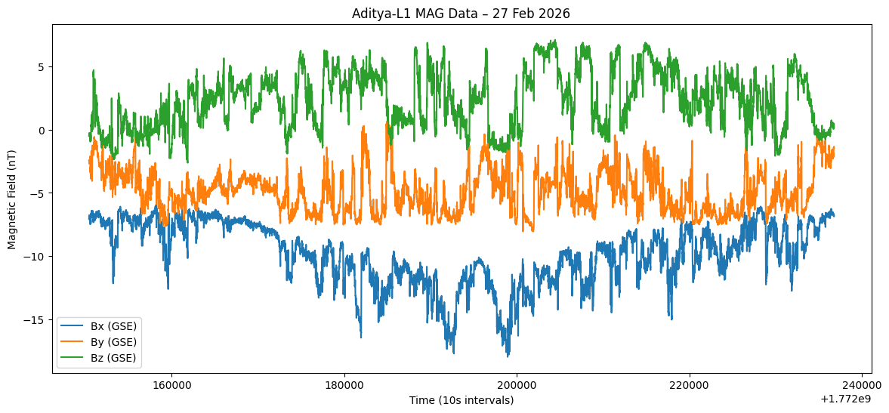

Total Magnetic Field Plot
The magnitude of the magnetic field varies between:
6.7 nT – 18.9 nT
This indicates moderate solar wind conditions.
plt.figure(figsize=(14,6))
plt.plot(time_utc, B_total, color='black')
plt.xlabel("UTC Time")
plt.ylabel("|B| (nT)")
plt.title("Total Magnetic Field Magnitude")
plt.xticks(rotation=45)
plt.show()

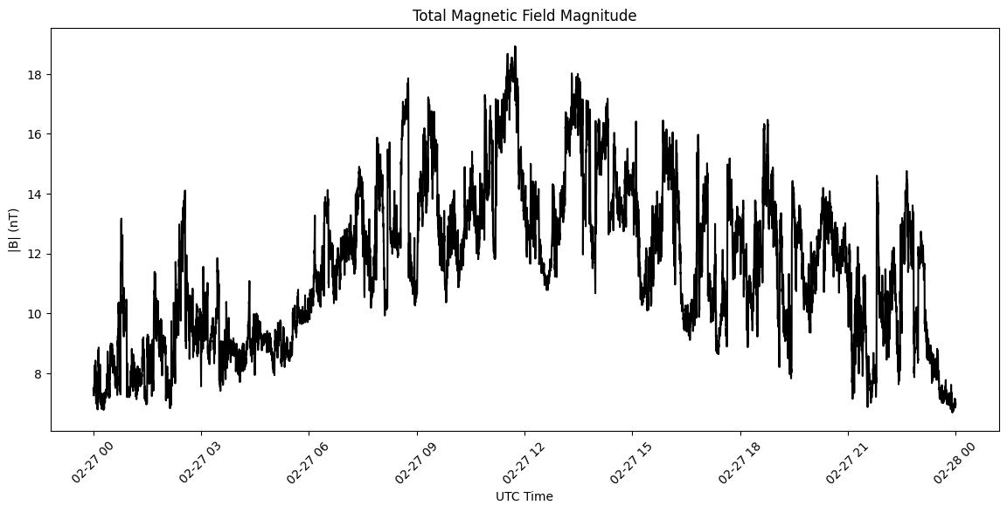

Histogram of Magnetic Field Strength
A histogram shows the distribution of magnetic field values.
Most measurements fall between 8 nT and 15 nT, which is typical for the solar wind near Earth.

plt.figure(figsize=(8,5))
plt.hist(B_total, bins=40)
plt.xlabel("|B| (nT)")
plt.ylabel("Frequency")
plt.title("Distribution of Magnetic Field Strength")
plt.show()

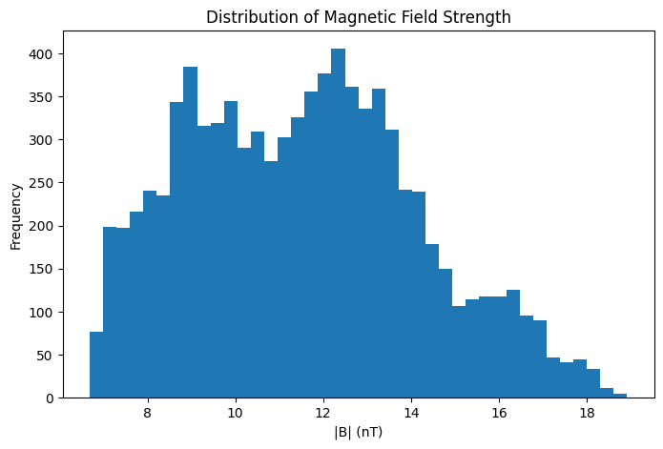

Parker Spiral Angle
The solar magnetic field forms a spiral structure known as the Parker Spiral due to the rotation of the Sun.
Using Bx and By, the spiral angle can be estimated to understand the orientation of the interplanetary magnetic field.

import numpy as np
# Parker spiral angle
theta = np.degrees(np.arctan2(by, bx))
plt.figure(figsize=(14,6))
plt.plot(time_utc, theta)
plt.xlabel("UTC Time")
plt.ylabel("Spiral Angle (degrees)")
plt.title("Parker Spiral Angle from Aditya-L1 MAG")
plt.xticks(rotation=45)
plt.show()

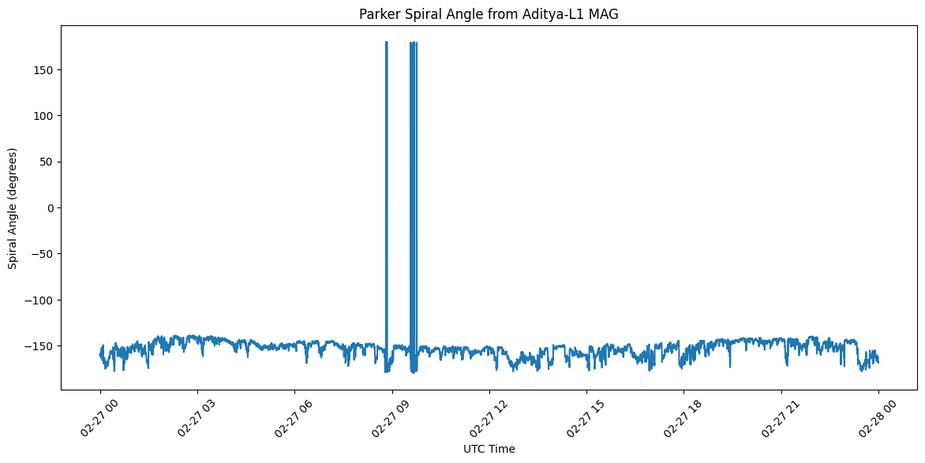

Hodogram Plot
A hodogram (Bx vs By) illustrates how the magnetic field vector rotates in space.
This method is commonly used in space plasma physics to study magnetic structures.
files = [
"L2_AL1_MAG_20260225_V00.nc",
"L2_AL1_MAG_20260226_V00.nc",
"L2_AL1_MAG_20260227_V00.nc",
"L2_AL1_MAG_20260228_V00.nc"
]
means = []
for f in files:
d = Dataset(f)
bx = d.variables['Bx_gse'][:]
by = d.variables['By_gse'][:]
bz = d.variables['Bz_gse'][:]
B = np.sqrt(bx**2 + by**2 + bz**2)
means.append(np.mean(B))
plt.figure(figsize=(8,5))
plt.plot(["25 Feb","26 Feb","27 Feb","28 Feb"], means, marker='o')
plt.ylabel("Mean |B| (nT)")
plt.title("Daily Magnetic Field Strength Comparison")
plt.show()

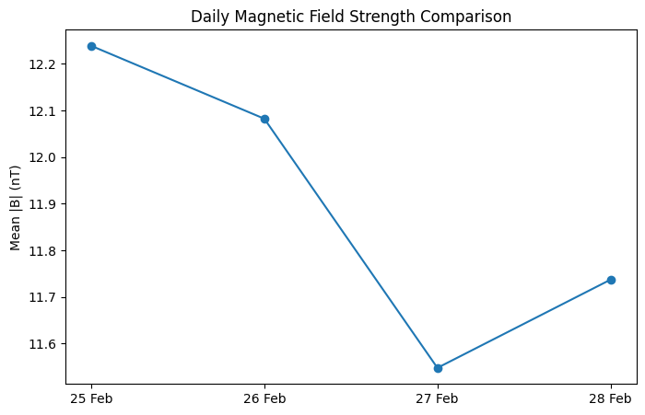

3D Magnetic Field Visualization
A 3D trajectory of Bx, By, and Bz shows how the magnetic field vector evolves in space.
This provides a visual representation of the magnetic field dynamics.
from mpl_toolkits.mplot3d import Axes3D
import matplotlib.pyplot as plt
fig = plt.figure(figsize=(8,6))
ax = fig.add_subplot(111, projection='3d')
ax.plot(bx, by, bz, color='blue')
ax.set_xlabel("Bx (nT)")
ax.set_ylabel("By (nT)")
ax.set_zlabel("Bz (nT)")
ax.set_title("3D Magnetic Field Vector Evolution (Aditya-L1 MAG)")
plt.show()

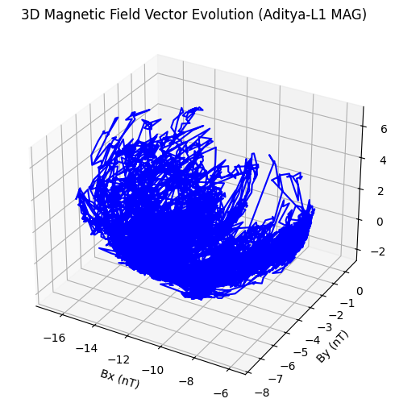

8. Disturbance Detection
To detect potential solar wind disturbances, a statistical threshold is defined:
Threshold = Mean + 2 × Standard Deviation
If the magnetic field magnitude exceeds this threshold, it may indicate a disturbance event.
In the analyzed dataset, no significant disturbance events were observed.

9. Scientific Interpretation
The analysis of the MAG dataset reveals:
- Mean magnetic field ≈ 11.5 nT
- Standard deviation ≈ 2.6 nT
- Moderate fluctuations in magnetic field components
The Bz component did not remain strongly negative for extended durations.
Since geomagnetic storms typically require sustained negative Bz values below −10 nT, the analyzed interval does not indicate strong geomagnetic storm conditions.
The solar wind environment during this period can therefore be classified as moderately stable.

10. Conclusion
This learning module demonstrates how Aditya-L1 MAG data can be used to study the interplanetary magnetic field.
Using Python-based analysis, we performed:
- dataset exploration
- statistical analysis
- visualization of magnetic field components
- detection of possible disturbance events
Element | Table-of-Contents | Aditya-L1-Analysis | Action
Key Stats | Missing | Complete | ADD
Code Snippets | Generic | Specific | EXPAND
Quality Fix | None | Detailed | ADD
Variable Table | Basic | Professional | UPGRADE
Validation | None | Checklist + Table | ADD
Exports | None | PNG/CSV code | ADD

The analysis shows moderate solar wind conditions with no major geomagnetic disturbances.
This workflow provides a foundation for students to analyze space physics datasets and understand solar wind behavior.

11. Learning Outcomes
After completing this module, students will be able to:
- understand the Aditya-L1 mission
- analyze solar wind magnetic field measurements
- interpret Bx, By, and Bz components
- compute magnetic field magnitude
- visualize space physics data using Python
- interpret space weather conditions
12.References
- Indian Space Research Organisation (ISRO).
Aditya-L1 Mission Overview.
https://www.isro.gov.in/Aditya_L1.html
- ISRO Science Data Archive (ISSDC).
PRADAN Data Access Portal for Aditya-L1 Mission Data.
https://pradan.issdc.gov.in/al1
- Indian Space Research Organisation (ISRO).
Aditya-L1 MAG Instrument and Payload Information.

